**SECTION 7: STRENGTHEN SELF-SOOTHING SKILLS**

**SELF-SOOTHING ACTIVITIES**

I am picking the following three self-soothing activities that I think I can try for the next ten days, when I feel

intensely emotional:

1

2

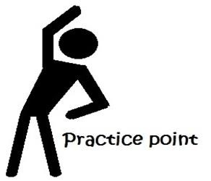3

**Instructions:** Please use the form given below for the next one week to observe and record the use of self-soothing activity when your distress increases.

**Exercise: Recording of your self-soothing activities**

|  |  |  |  |  |
| --- | --- | --- | --- | --- |
| Date and time | Severity of initial distress  (Indicate your rating on 0 to 10 scale) | Used a healthy self-soothing activity  (Name the activity) | Severity of distress After using self- soothing  (Indicate your rating on 0 to 10 scale) | Plan for the next time  (Based on your observation, plan what you might want to do next  time |
| Example | 8  (Quite anxious) | Listened to a song | 5 | Keep music handy |
|  |  |  |  |  |
|  |  |  |  |  |
| Date and time | Severity of initial distress  (Indicate your rating on 0 to 10 scale) | Used a healthy self-soothing activity  (Name the activity) | Severity of distress After using self- soothing  (Indicate your rating on 0 to 10 scale) | Plan for the next time  (Based on your observation, plan what you might want to do next  time |
|  |  |  |  |  |
|  |  |  |  |  |
|  |  |  |  |  |
|  |  |  |  |  |
|  |  |  |  |  |
|  |  |  |  |  |
|  |  |  |  |  |